The website is in l the XML file in google drive. Hopefull that should work to import back to squarespace. This also has all the most current text and screenshots

___________________________________________

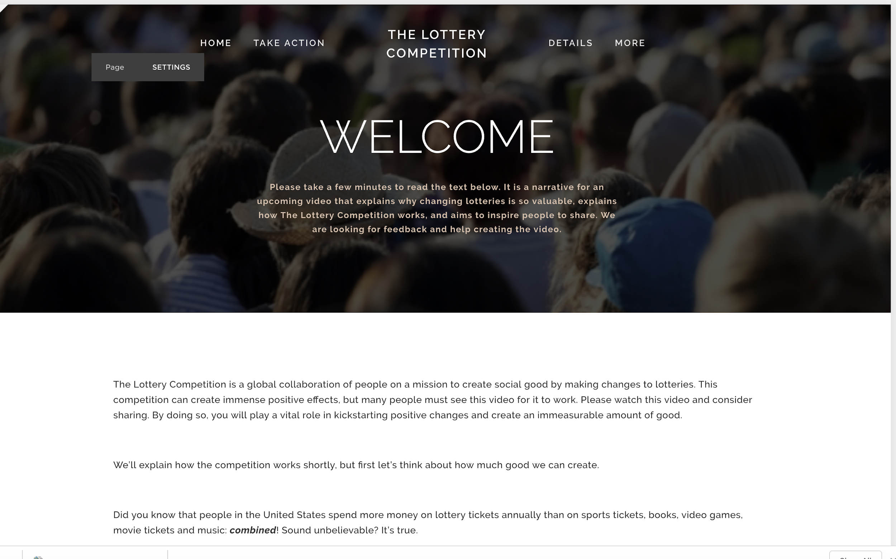

# **[THE LOTTERY COMPETITION](https://steven-oustecky-gg8f.squarespace.com/)**

[HOME](https://steven-oustecky-gg8f.squarespace.com/)

[TAKE ACTION](https://steven-oustecky-gg8f.squarespace.com/takeaction/)

[DETAILS](https://steven-oustecky-gg8f.squarespace.com/details/)

MORE

[CONNECT](https://steven-oustecky-gg8f.squarespace.com/connect/)

[ABOUT](https://steven-oustecky-gg8f.squarespace.com/about/)

[](https://steven-oustecky-gg8f.squarespace.com/about/)

# WELCOME

**Please take a few minutes to read the text below. It is a narrative for an upcoming video that explains why changing lotteries is so valuable, explains how The Lottery Competition works, and aims to inspire people to share. We are looking for feedback and help creating the video.**

The Lottery Competition is a global collaboration of people on a mission to create social good by making changes to lotteries. This competition can create immense positive effects, but many people must see this video for it to work. Please watch this video and consider sharing. By doing so, you will play a vital role in kickstarting positive changes and create an immeasurable amount of good.

We’ll explain how the competition works shortly, but first let’s think about how much good we can create.

Did you know that people in the United States spend more money on lottery tickets annually than on sports tickets, books, video games, movie tickets and music: ***combined***! Sound unbelievable? It’s true.

Around the world, **hundreds of millions of people** participate in lotteries and in just the past year... people spent around **280 billion dollars**on lottery tickets. Now that's a huge number. To get a grasp on how much money that is, consider that (in 2008) the United Nations estimated that it would take *30 billion dollars per year to end world hunger****.***

Take a moment to think about that. People spend nearly ten times that much playing lotteries!

Because lotteries operate on such a large scale, it means that they have *really big effects* on our society. And these effects can be both positive *and* negative.

Lotteries can help countless people by raising funds for good causes (such as education and public infrastructure). Lotteries are one of the biggest fundraisers in the world. Every year, they direct about $76 billion globally (or 27% of total revenue) to these kinds of causes.

On the other hand, lotteries can negatively affect countless people by operating public gambling in irresponsible ways. Lotteries have been criticized for things like for predatory advertising and, in some cases, corrupt lottery officials were charged with stealing public money. Lotteries are one of the biggest operators of public gambling in the world, which means that negative effects caused by irresponsible operations are amplified.

The mixed effects that lotteries create cause people to disagree about how lotteries should be handled. However, one thing that we can all agree on is that some kind of changes should be made to make things better. We don't know what the best solutions are; Our goal is to inspire problem solvers to think about it and experiment to find what works best.

What if, for example, lotteries were operated with a policy of complete transparency, using the internet to publicly share their financial records and let people know exactly where all of the money is going?

What if lotteries spent less time talking about big prizes, and more time talking about raising funds for good causes?

Could unhealthy gambling behavior be reduced if lotteries designed their playing environments differently? Or making other changes?

Is it possible for lotteries to use their unique role in society to bring people together in a spirit of helping others?

How about reducing operating costs and using the savings to provide more funds to good causes?

Lotteries spend an average of 5% of revenue on operating expenses (things like retailer fees, printing tickets, and administration fees), which amounts to approximately $14 billionper year globally.

Can any of these expenses be reduced? How much more money could be provided to good causes? How many people could that help?

And, while on the subject of improving fundraising operations, is there any way that funds could be used differently to provide more value to our society?

Perhaps lotteries could take an analytical approach to determine the most socially beneficial causes and organizations to direct funding to.

Would it be better if players could decide to fund the causes they find the most meaningful or important?

Maybe there are completely different ideas that would produce more benefits!

While we're not sure which changes would work best, we are sure that the stakes are high. When you consider the huge scale of lotteries, it's clear that even relatively small changes have the potential to help many millions of people.

We also know that lotteries have been relatively slow to make changes like these. There are many reasons why: things like slow government processes, tight restrictions, and little motivation or incentive for people to make changes. But there's no reason why changes*can’t* be made.

**It just needs a spark.** That’s why we’re launching The Lottery Competition.

So here’s the plan:

We are challenging problem solvers around the world to create social good by fostering changes in lotteries. Anybody can take up the challenge and compete to win The Lottery Competition. Competitors could be social entrepreneurs, filmmakers, lottery operators, activists, or… anybody who wants to create social good. It doesn’t matter where they live, if they have experience with lotteries, or what type of solution they use (as long as it’s legal). Whoever creates the most positive impact will win the competition. This will be decided by public vote.

To provide incentive for these problem solvers, we are raising money for a prize to award to the winning team. To encourage new ideas and solutions, we are compiling an extensive amount of information about lotteries and starting discussion forums on TheLotteryCompetition.org. When one team of problem solvers succeeds in making a positive change to a lottery anywhere in the world, it will provide an example that all other lotteries can follow. By holding a public competition in this way, we aim to set off a domino effect of socially beneficial changes as we move forward in the 21st century.

Together, we have the power to shape our future, but it will require many people to take small actions on an individual level to get there. You can learn about ways to get involved at TheLotteryCompetition.org but...

The most important thing we need to do now is spread the word.

The Lottery Competition will only work if many people see this video and we need your help to make that happen.

Please... **share** this video now to help make these changes.

Thanks for watching

_______________________________________________

________________________________________________

-------------------------------------------------------

Thanks for reading the narrative for The Lottery Competition. We look forward to hearing your thoughts. Any feedback you can provide will help launch the competition successfully and kickstart positive changes. Email us at feedback@TheLotteryCompetition.org or contact us[here](https://steven-oustecky-gg8f.squarespace.com/connect).

Check out [this page](https://steven-oustecky-gg8f.squarespace.com/takeaction-1) to learn how to get involved.

Click [here](https://steven-oustecky-gg8f.squarespace.com/details) if you want learn more of the details. It describes:

* How The Lottery Competition actually fosters socially beneficial changes
* Problems currently associated with lotteries
* Reasons why these problems exist
* Examples of changes that may be made that could create long-term social good
* Details about how The Lottery Competition will actually work, with information such as:
  + Criteria for Judging
  + Duration/Prizes
  + Who can Participate
  + Who can Compete
  + Selection of Winner
  + Registration and Submission

*Please note that the site is still in development and is subject to change as we prepare to publicly launch the competition. Please also note that technical details (like the dates, prize amounts, etc) are subject to change before the official launch. All of the sources for financial estimates in this narrative can be found* [*here*](https://www.thelotterycompetition.org/financialestimates)*. Entries must comply with all jurisdictional laws in order to be eligible to win. The Lottery Competition expressly discourages and is not responsible for any entries that violate laws and regulations. All prizes awarded to the winner(s) are subject to the amount of money raised in the crowdfunding campaign and sponsorships.*

Powered by [Squarespace](http://www.squarespace.com/)

_______________________________________________________________________________________________________________________________________________________________________________________________________________________

# **[THE LOTTERY COMPETITION](https://steven-oustecky-gg8f.squarespace.com/)**

[HOME](https://steven-oustecky-gg8f.squarespace.com/)

[TAKE ACTION](https://steven-oustecky-gg8f.squarespace.com/takeaction/)

[DETAILS](https://steven-oustecky-gg8f.squarespace.com/details/)

MORE

[CONNECT](https://steven-oustecky-gg8f.squarespace.com/connect/)

[ABOUT](https://steven-oustecky-gg8f.squarespace.com/about/)

[](https://steven-oustecky-gg8f.squarespace.com/about/)

# TAKE ACTION

There are many ways you can help kickstart positive changes. They include:

## **HELP US LAUNCH**

The competition is now open for funding and competitors to enter, but the most important moment is just about to happen: The Lottery Competition is about to launch! To be successful in kickstarting positive changes, this launch needs to attract attention and inspire people to take action. At this time, there are two priorities:

1. Create the video.

This will serve as the main way to spread the idea on social media. Please email us if you or someone you know may be interested in helping to create the video.

2. Finalize all details and improve the website.

How can we make The Lottery Competition better? Please share your thoughts on [reddit](https://www.reddit.com/r/TheLotteryCompetition/) or via email. Critical/constructive feedback is encouraged.

## **SHARE**

**The most important thing we need to do is spread the word. Share this site with your social networks and talk about The Lottery Competition with friends and family.**





**FOLLOW**



**LIKE**



## **FUND**

We are raising money for a prize to award to the team(s) that create the most social good by fostering changes to lotteries (TBD by public vote). Our crowdfunding goal is currently set at $1 million.

Fund the competition on HeroX. HeroX functions like Kickstarter, so funding will only be collected if/when the funding goal is reached. HeroX does **not** charge any fees. The Lottery Competition (and the creators) are **not** making any money.

[Click here to go to the funding page](https://herox.com/thelotterycompetition)

## **DISCUSS**

Share ideas about changing lotteries on [reddit](https://www.reddit.com/r/TheLotteryCompetition/) and social media. Check out the [details page](https://steven-oustecky-gg8f.squarespace.com/details) for more discussion material.



**VISIT**

## **COMPETE**

We are challenging problem solvers around the world to create social good by fostering changes in lotteries. Anybody can take up the challenge and compete to win The Lottery Competition. Competitors could be social entrepreneurs, filmmakers, lottery operators, activists, or… anybody who wants to create social good. It doesn’t matter where they live, if they have experience with lotteries, or what type of solution they use (as long as it’s legal). Whoever creates the most positive impact will win the competition. This will be decided by public vote. Enter to compete in the competition on HeroX. Details can be found [here](https://steven-oustecky-gg8f.squarespace.com/details).

[Click here to go to the competition page](https://herox.com/thelotterycompetition)

## **SPONSOR**

Contact us at sponsor@thelotterycompetition.org to talk about sponsoring The Lottery Competition.

We are looking for organizations or individuals to sponsor the prize and/or the competition itself.

## **VOLUNTEER**

Contact us at volunteer@thelotterycompetition.org to talk about volunteer opportunities. We are looking for assistance with:

Social media management, branding, web development, public relations, promotions

Powered by [Squarespace](http://www.squarespace.com/)

____________________________________________________________________________________________________________________________________________________________________________

# **[THE LOTTERY COMPETITION](https://steven-oustecky-gg8f.squarespace.com/)**

[HOME](https://steven-oustecky-gg8f.squarespace.com/)

[TAKE ACTION](https://steven-oustecky-gg8f.squarespace.com/takeaction/)

[DETAILS](https://steven-oustecky-gg8f.squarespace.com/details/)

MORE

[CONNECT](https://steven-oustecky-gg8f.squarespace.com/connect/)

[ABOUT](https://steven-oustecky-gg8f.squarespace.com/about/)

[](https://steven-oustecky-gg8f.squarespace.com/about/)

This page provides an in-depth description of The Lottery Competition. It also analyzes the social effects of lotteries and considers how social good may be created. It is organized into the following sections:

[1. How the winner will be decided](https://steven-oustecky-gg8f.squarespace.com/details/#howto)

[2. The primary problem that The Lottery Competition aims to solve](https://steven-oustecky-gg8f.squarespace.com/details/#primary)

[3. How The Lottery Competition solves the primary problem and fosters socially beneficial changes](https://steven-oustecky-gg8f.squarespace.com/details/#solve)

[4. Specific problems currently associated with lotteries](https://steven-oustecky-gg8f.squarespace.com/details/#specific)

[5. Examples of changes that could create long-term social good](https://steven-oustecky-gg8f.squarespace.com/details/#examples)

[6. Reasons why lotteries have been relatively slow to make changes](https://steven-oustecky-gg8f.squarespace.com/details/#reasons)

[7. Technical details](https://steven-oustecky-gg8f.squarespace.com/details/#details)

* [Criteria for Judging](https://steven-oustecky-gg8f.squarespace.com/details/#criteria)
* [Duration/Prizes](https://steven-oustecky-gg8f.squarespace.com/details/#duration)
* [Who can Participate](https://steven-oustecky-gg8f.squarespace.com/details/#whocan)
* [Who can Compete](https://steven-oustecky-gg8f.squarespace.com/details/#compete)
* [Selection of Winner](https://steven-oustecky-gg8f.squarespace.com/details/#selection)
* [Registration and Submission](https://steven-oustecky-gg8f.squarespace.com/details/#registration)

[8. Financial estimations](https://steven-oustecky-gg8f.squarespace.com/financialestimates)

**HOW THE WINNER WILL BE DECIDED**

The winner of The Lottery Competition will be a team or individual who creates the most social good by fostering a change to the way lotteries operate.

The winner will be determined by a public vote on date TBA.

**THE PRIMARY PROBLEM**

Lotteries around the world have been relatively slow to make changes that would create more positive effects for society.

There are two ways in which a lack of changes in lotteries are preventing more positive effects for society:

1. Lotteries have problems that adversely affect individuals and communities. These problems adversely affect countless people. Changes can be made to fix or minimize these problems and reduce negative effects caused by lotteries.
3. Lotteries have problems that limit the amount of social good they create as fundraisers for good causes. These problems prevent lotteries from positively affecting countless people. changes can be made to fix or minimize these problems and increase positive effects created by lotteries.

Hundreds of millions of people play lotteries every year and an estimated 280 billion dollars were spent on lotteries tickets around the world in 2015 [(1)](https://www.world-lotteries.org/images/publications/compendia/wla-compendium-2016-rev1.pdf).

In the United States. people spend more money on lottery tickets annually than on sports tickets, books, video games, movie tickets and music- combined! [(2)](http://money.cnn.com/2015/02/11/news/companies/lottery-spending/)

Because lotteries operate on such a large scale, the effects caused by problems within lotteries are amplified and changes have the potential to create immense positive impacts for our society.

(1)<https://www.world-lotteries.org/images/publications/compendia/wla-compendium-2016-rev1.pdf>

(2) http://money.cnn.com/2015/02/11/news/companies/lottery-spending/

**HOW THE LOTTERY COMPETITION ACCELERATES CHANGES IN LOTTERIES TO FOSTER LONG-TERM SOCIAL GOOD**

This competition aims to provide a breakthrough for the primary problem and catalyze socially beneficial changes in the following ways:

a) Spreading awareness of how large of an effect lotteries have in our society.

Collecting and sharing relevant information in one location to show all of the effects of lotteries (both negative and positive) as objectively and thoroughly as possible. This information includes (but is not limited to) financial estimates, articles, news programs, documentaries and editorials about lotteries.

Inviting individuals from anywhere in the world (regardless of their prior experience with lotteries) to take part in sharing information about lotteries and their social effects.

b) Encouraging public, proactive discussions to decide how we, as a society, want to handle our lotteries going forward in the 21st century and providing a common ground where people can work together to discuss potential ways to improve lotteries.

Creating discussion forums and sharing ideas about potential changes (and the social good that may be created by changes) to serve as inspiration for problem solvers to think of ways to create social good.

Inviting individuals from anywhere in the world (regardless of their prior experience with lotteries) to share ideas and opinions aimed at creating social good.

c) Empowering individuals from all over the world to help make changes in lotteries to create social good. In addition to sharing ideas and information about lotteries, everybody can play a part in creating social good by participating in the public vote, contributing to the crowdfunding campaign, and/or spreading awareness/excitement about improving lotteries to create social good with their communities and social networks.

d) Generating public attention, interest and excitement about finding solutions to create social good by holding the competition and crowdfunding campaign in an all-inclusive, public manner.

f) Crowdfunding a prize to provide monetary and personal incentives for problem solvers to focus time and effort on actually implementing changes to foster social good.

Building emotional support and enthusiasm for competitors by holding the crowdfunding campaign and competition in a public manner.

Because an unlimited amount of problem solvers are allowed to enter the competition, all types of innovations can be tested and experimented in order to find the most socially beneficial solutions.

g) Spurring innovations from a variety of angles by encouraging solutions from all different types of problem solvers and methods.

NOTE: Although only one team will win The Lottery Competition, the competition aims to catalyze long-term and resounding positive social effects all around the world. It does so in these ways:

Rewarding and publicly celebrating the team operating the winning lottery to bring attention to successful implementations of changes that foster positive social effects. The successful implementation of effective solutions can set an example for other lotteries around the world to learn from in the future

Potentially inspiring pro-active and constructive approaches to other issues, unrelated to lotteries.

**THE PROBLEMS THAT COULD BE FIXED OR MINIMIZED BY MAKING CHANGES**

There are at least four specific problems that could be fixed or minimized by making changes in lotteries. These problems are (in no particular order):

1. **Lotteries do not always conduct their public communications and structure their playing environments in the ways that foster the most positive social effects. There are three ways in which this problem manifests:**

a) **Lotteries do not always act responsibly as operators of public gambling games.**

Lotteries inherently involve public gambling, which comes with the risk that some participants may play when it is not in their best interests (such as when they have small discretionary incomes or when a gambling addiction occurs). This kind of gambling behavior can cause harm to themselves and their community.

This means that lottery operators have an important duty to operate as responsibly as possible in order to limit the risks to participants and society as a whole.

However, in some cases, lotteries have been criticized for encouraging unhealthy gambling behaviors (see examples TLC.org/criticisms of lotteries). It is also possible that some decisions that lottery operators frequently make, such as focusing their advertising on big prizes and maintaining relatively impersonal playing environments, may increase these kinds of gambling risks. As long as lotteries operate public gambling games, there may always be some level of unavoidable risk that creates negative effects, but the amount of risk can vary greatly depending on the ways that lotteries communicate with the public and how they structure their playing environment.

b) **Lotteries may frequently miss an opportunity to use their unique role in our society to bring people together in a spirit of contributing to social good.** Lotteries raise an enormous amount of funding for good causes, but this isn’t always apparent because of the way that lotteries design their communications and environments (and the social good that lotteries do create is often overshadowed by criticisms of problems within lotteries). Lotteries are fundamentally similar to charity raffles, but charity raffles are often highly regarded for bringing people together to raise money for good causes and for promoting positive social values. Lotteries rarely seem to have this kind of effect today, but there are indications that they could if the right changes are made.

c) **Lotteries have a large influence on our culture because they receive so much attention in our society, but this influence isn’t always as positive as it could be.** In addition to directly affecting participants, lotteries may indirectly influence our society in wide ranging ways (and affect how people think about issues other than lotteries). For example, people who are dissatisfied with problems in lotteries may be more likely to be dissatisfied with the ways that societies or governments operate in general. This cultural influence (and whether it's positive or negative) may vary depending on the ways that lotteries communicate with the public, structure their playing environment, and on how lotteries handle the next three problems described.

2. **Lotteries do not always operate transparently, which makes lotteries more vulnerable to corruption.** In 2015, for example, over 2.7 billion dollars from the Chinese state lottery were determined to be misappropriated by officials (more examples can be found on TLC.org/criticisms/corruption). Every dollar that is lost to corruption is a dollar that is not going to good causes.

**Additionally, when people don’t know exactly where their money goes, people lose trust in lotteries and are less likely to feel good about contributing to good causes.**

3.  **Lotteries often have high operating costs, which can decrease the amount of money that they can use to fund good causes.** Each lottery is different, but it is common for lotteries to spend approximately 5% ($14B per year globally) of their total revenue on operating expenses [(3)](http://www.nytimes.com/2008/06/04/news/04iht-04food.13446176.html).

These expenses often include (but are not limited to): paying retailer commissions, printing tickets, shipping tickets to retailers, purchasing and maintaining ticket machines, advertising, employee salaries, and administration expenses. [(4)](http://fivethirtyeight.com/datalab/what-percentage-of-state-lottery-money-goes-to-the-state/) Because lotteries do not always quickly adopt innovations, it is possible that some of these expenses could be reduced or avoided by implementing new technologies or business practices.

In order to understand how large of an effect that reducing operating expenses may have, it’s important to emphasize the enormous size of lotteries. Approximately 280 billion dollars are spent globally per year on lottery tickets, which means that the annual operating expenses (when estimated at 5% of revenue as the global average) of lotteries is around 14 billion dollars per year. **For some perspective, consider that that the United Nations estimated (in 2008) that it would take 30 billion dollars per year to end world hunger** [(5)](http://www.nytimes.com/2008/06/04/news/04iht-04food.13446176.html).

Because so much money is spent on lotteries around the world, even small reductions in operating costs could potentially provide billions of dollars more to good causes.

4.  **Lotteries don’t always direct their funding to the causes/organizations that would provide the most benefit for society. Additionally, lotteries do not always direct their funding toward causes that participants think are the most meaningful (or important) to contribute to.** Each lottery operates differently, but it is common for lotteries to dedicate 27% of their total revenue to good causes. This amounts to approximately $76 billion per year combined in all lotteries) to fund good causes [(6)](https://www.world-lotteries.org/images/publications/compendia/wla-compendium-2016-rev1.pdf). (see www.thelotterycompetition.org for a breakdown of how this estimate was made).

Each lottery also allocates their funding in different ways, but it is common for funds to be directed towards public education, investments in infrastructure, and other public projects. The allocation is usually decided by the lottery operators.

The funds that lotteries provide to these causes certainly have and continue to benefit society, but it is possible that the ways that lotteries are allocating funds are not:

*a) providing the highest leverage returns on creating social good (or in other words, they may not be creating the most social benefit per dollar funded).*

Other organizations that must decide how to allocate large amounts of funds (such as financial firms or philanthropic foundations that apply principles of ‘effective altruism’) have learned that there are often large differences in the amount of returns generated from different allocations.

Considering the immense amount of funds that lotteries raise for good causes (approximately $76 billion per year), even small differences in how much social benefit different causes create could result in a large difference in how much total social good the funds create.

*b) providing funding for what participants and society (as a whole) value the most.*

People have a wide range of preferences when deciding which causes and organizations to contribute to. It is possible that allocating funding differently could affect participants’ intentions and attitudes, while also altering how societies view lotteries.

Considering the immense amount of people who participate in lotteries, it is possible that aligning funds with participant and societal values could have a large effect in creating social good.

(3) http://www.nytimes.com/2008/06/04/news/04iht-04food.13446176.html

(4) http://fivethirtyeight.com/datalab/what-percentage-of-state-lottery-money-goes-to-the-state/

(5) http://www.nytimes.com/2008/06/04/news/04iht-04food.13446176.html

(6) <https://www.world-lotteries.org/images/publications/compendia/wla-compendium-2016-rev1.pdf>

**HOW CHANGES CAN BE MADE TO LOTTERIES TO CREATE SOCIAL GOOD**

**There are many ways that lotteries may be changed to create social good.**

**The following describes multiple ways that social good may be created (and includes ideas about potential changes that may be implemented). *It is formatted according to the four specific problems identified earlier:***

*Please note: All of the ideas described below are only intended to serve as inspiration for ideas about potential changes that problem solvers may implement. It is possible that some of the ideas described below would not be good solutions and it is also possible that problem solvers may find solutions that are entirely different from what is described here.*

**1. Conduct public communications and structure playing environment in ways that foster the most positive social effects. There are three ways that this may manifest to create social good:**

**A)** **Adhere to a policy of operating as responsibly as possible to minimize the risks and negative effects associated with gambling. This could create social good by reducing negative effects on both individuals and communities.**

**B) Use lotteries’ unique role in society to foster a collective spirit of contributing to good causes and promoting positive values. This could create social good by increasing positive effects on both individuals and communities.**

**C) These changes (as well as changes to the other three specific problems described) may also create social good by positively affecting lotteries’ influence on our culture.**

**Potential changes that could foster these positive effects include:**

* Conduct public communications in a way which promotes positive values and discourages unhealthy behavior.
* Focus advertising and games more on social betterment and less on big prizes.
* Encourage safe and responsibly playing behavior. These messages are most effective when they are highly visible, memorable, and repeated.
* Increase public awareness of the risks of gambling.
* Establish and frequently refer to protocols and/or checklists to ensure communications are conducted in the most responsible ways.
* Establish a trusted board, independent organization, or online system driven by volunteer crowd collaboration (perhaps like wikipedia) to review lottery communications.
* Study fundraisers and charitable organizations to understand and implement elements which contribute to socially beneficial communications.
* Design and maintain a playing environment that promotes positive values and discourages unhealthy behavior.
* Mediate the sale of tickets in environments which have been designed to integrate social norms and codes of conduct which encourage safe playing behavior and promote positive values.
* Structure live, in-person environments and events that encourage safe playing behavior and promote positive values. For example, events held to celebrate funding raised for good causes. (examples on TLC.org dutch UK)
* Design and integrate social media experiences to create social environments where people come together to encourage safe playing behavior and foster positive values.
* Study charity raffles to understand and implement elements which contribute to positive playing environments.

**Potential changes that could reduce unhealthy gambling behaviors include:**

* Make gambling services and programs designed to help people with gambling problems easily accessible to all participants. Examples of services that might be helpful include hotlines, interactive experiences on the internet, local support groups, and rehabilitation clinics.
* Lotteries (or socially driven volunteers) could conduct research and/or experiments to find the most effective solutions to limit negative effects caused by gambling.
* Operate as (the legal equivalent of) a non-profit organization. This may reduce any profit incentive which might entice lottery operators to make decisions that conflict with public good.
* *Please note: No matter what what changes are made to lotteries, it is possible that there still may be gambling risks and negative effects caused by lotteries. For this reason, there has been some debate that the most socially beneficial solution could be to prohibit lotteries from offering public gambling games. The Lottery Competition encourages this kind of discussion and any other discussions aimed at creating social good. The Lottery Competition is agnostic towards whatever changes are made so long as they are made for the benefit of society.*

2. **Implement a policy of complete transparency, which could create social good by:**

**A) Reducing money that is lost to corruption and using that money to direct more funds towards good causes.**

**B) Increasing trust with participants and making people feel better about contributions to good causes.**

**Potential changes that could be made to make a lottery completely transparent include:**

* Regularly posting all financial and operational information online (For examples of how other charitable organizations have shared their information publicly, please see TLC.org in fundraising).
* Regularly conduct internal audits and undergo external audits to make sure the information released is fully accurate and representative of all of lottery operations. This might be handled by a trusted board, independent organization , or volunteer online crowd collaboration driven by by social purpose (like wikipedia). (Examples at TLC.org)
* Use a technology such as blockchain for transactions, which would create a (theoretically unhackable) public record of all transactions.
* Operate as (the legal equivalent of) a non-profit organization. This may reduce any profit incentive which might entice lottery operators to make decisions that conflict with public good.

3. **Minimize operating costs and use the savings to increase funds provided to good causes.**

**This could create social good by providing more funds to good causes and organizations, which would use the added funds to benefit society.**

**As described earlier,** it is important to emphasize the enormous size of lotteries to understand how much social good might be created. Approximately 280 billion dollars are spent globally per year on lottery tickets, which means that the annual operating expenses (when estimated at 5-10% of revenue as the global average) of lotteries are around 14-28 billion dollars per year (source). For some perspective, consider that that the United Nations has estimated that it would take $30B per year to end world hunger (source). Because so much money is spent on lotteries around the world, even small reductions in operating costs could potentially provide billions of dollars more to good causes.

**Potential changes that could be made to reduce operating costs include:**

* Regularly conduct internal audits and undergo external audits to ensure funds are not being wasted. This might be handled by a trusted board, independent organization , or volunteer online crowd collaboration motivated by social purpose (like the crowd collaboration which develops wikipedia) . (Examples at TLC.org)
* Reduce advertising expenses, which may be achieved by:
* a) Advertising less
* b) Advertising in less expensive locations and mediums. For example, a lottery could advertise less on TV and focus more efforts on building social media presence.
* c) Promoting the social benefit created by raised funds, which may increase free ‘word of mouth’ marketing from people motivated by social purpose.
* Refine distribution and/or sales methods
* a) Negotiating contracts with retailers to lower commissions. Retailer commissions may also be lowered by working with organizations that have aligned interests in creating social good.
* Implement new distribution and/or sales methods
* a) Conducting ticket sales online could drastically reduce expenses such as retailer fees, shipping tickets, maintaining ticket machines, and printing tickets.
* b) Implementing a technology like blockchain could potentially reduce even more expenses.

*Please note: Selling tickets online, however, may increase risks of unhealthy gambling behavior because it could make it easier for participants to play when it is not in their best interest. Legal restrictions also might make online sales particularly difficult to implement. For both of these reasons, potential changes like these should not be made unless these reasons are carefully considered and handled responsibly.*

* Base operation out of a country/jurisdiction where there are less fees and/or restrictions.
* Communicate with local authorities to find ways to lower fees and/or other expenses that result from regulations.
* Outsource tasks that can be done by volunteers who are motivated by doing social good.
* Explore tools and technologies that may help foster innovations to reduce expenses. Examples of these could include software and websites like Slack, Evernote, Kickstarter, HeroX, or Github.
* Explore tools and practices that have been effectively implemented in private companies to foster more creativity and productivity from employees. Examples include workspace design, providing space for exercise and play, providing space for meditation, standing desks, and productivity systems like GTD.

4. **Direct funding to the causes or organizations that would create the most positive effects for society.**

**There are at least two ways this can be approached to create social good:**

**A) Implement a systematic process to direct funding to the causes/organizations that would provide the most benefit for society. This could create social good by enabling the most socially beneficial organizations to maximize their positive impacts.**

Considering the immense amount of funds that lotteries raise for good causes (approximately $80 billion per year (source), even small differences in how much social benefit different causes create could result in a big difference in how much total social good the funds create.

**Potential changes that could be made to systematically direct funding to the most socially beneficial causes/organizations include:**

* Considering quantifiable metrics when deciding how to allocate funds. For example, lotteries could use the same metrics that people use when applying principles of ‘effective altruism’ to determine the most socially beneficial allocations of funding. These metrics include **overhead ratios** (amount of money the organization/causes spend compared to the amount of money spent on contributing to social good), **DALY**’s (Disability-Adjusted Life-Years) and **QALY**’s (quality-adjusted life-year).

(sources or more info:

http://www.theatlantic.com/business/archive/2015/06/what-is-the-greatest-good/395768/

https://en.wikipedia.org/wiki/Disability-adjusted_life_year

https://en.wikipedia.org/wiki/Quality-adjusted_life_year

(metrics like these are also being developed-

https://opentheory.net/2015/06/effective-altruism-and-building-a-better-qaly/)

* Considering published ratings and rankings of causes and organizations when deciding how to allocate funds. For example, organizations like GiveWell, the Open Philanthropy Project, and Charity Navigator have systematically analyzed causes and charitable organizations to determine the most beneficial ways to direct funding.

http://www.givewell.org/charities/top-charities

http://www.openphilanthropy.org/research/cause-reports

http://www.charitynavigator.org/

* Implement a technology like blockchain, which could potentially use smart contracts to automate the allocation of funds according to algorithms aimed at creating most social good.

B) **Implement a process that allows members of society or participants to participate in deciding how to direct funding to causes and/or organizations. This could create social good by aligning funding with the causes and organizations that people find most meaningful or important to contribute to.**

**Potential changes that could be made to align funding with the causes/organizations that people value most include:**

* Implement a process where individual participants can choose what organization/causes the fundraising portion of their ticket expense will be directed to. This process could be conducted at the point of purchase or in an online account.
* Implement a system where members of society or participants can vote to decide where the funds will be directed. This may be conducted online, in paper, or using a technology like blockchain.
* Focus the fundraising activities of a lottery on a specific, niche issue. For example, a lottery could dedicate all funds raised to cancer research.

**Note: With either of these approaches, social good may also be created by allowing funds raised by lotteries to be used more flexibly.** Lotteries often deal with cash, which means that the funds they raise have the ability to contribute to social good in a large variety of ways. Funds raised by lotteries potentially could be flexibly allocated to:

* Causes and organizations on local community, national, or international scales
* Immediate needs (such as relief programs for natural disasters) or long-term projects
* Large organizations, small start-ups, or communal projects
* Any type of cause or organization which could benefit from cash funding

**Potential changes that could allow funds to be used more flexibly include:**

* Form partnerships with charitable organizations
* Implement systems or procedures to allow more socially beneficial ventures to gain access to funds raised by lotteries. The UK’s Big Lottery, for example, has implemented this kind of system.

https://www.biglotteryfund.org.uk/funding/funding-guidance/applying-for-funding

https://www.biglotteryfund.org.uk/funding/funding-finde

Other ideas include:

Lottery operates as (the legal equivalent of) a non-profit organization.

Lottery operators earn a reasonable compensation and will not have any incentive for personal or monetary gain that could run in conflict with creating benefit for society as a whole.

Lottery operates with a primary purpose of creating social good, which serves as a guiding principle for all operating decisions.

Lottery distributes prize money over a greater number of smaller prizes.

**WHY LOTTERIES BEEN RELATIVELY SLOW TO MAKE CHANGES THAT WOULD BENEFIT SOCIETY**

There are two interconnected reasons why lotteries have been slow to make changes that would fix or minimize the problems stated above:

1. Lotteries have been operated by state agencies that:

a) Almost always enforce tight regulations that restrict how lotteries can be operated and who can operate lotteries, which has eliminated competition that could provide incentive for changes. In most places, the only lottery that is available is operated by the state or national government. Governments likely created such tight regulations to protect members of society from irresponsible lottery operations and reduce gambling risks, but these same regulations are also slowing lotteries from making changes that would allow them to become more responsible and have a more positive effect overall.

b) Are often subject to relatively long bureaucratic processing times. Many of the changes which could create positive effects for society have only recently become possible because they involve new technologies or new ways of thinking that didn’t existed before. Lotteries haven’t adopted these new changes as quickly as organizations in the private and nonprofit sectors because governments often need to take more steps to make changes.

c) Are often operated by officials that don’t have a personal incentive to make changes that could create social good. Also, in situations where corruption has developed, officials may have profit incentive that is in conflict with creating social good.

2. The public has not made a cohesive effort to encourage changes to lotteries.

While many people have published criticisms of lotteries and some organizations have formed to encourage changes, there has not yet been an undertaking that is substantial and action-oriented enough to succeed in actually making large changes to lotteries.

There are several possible reasons for this:

a) For most people, lotteries are only a small part of life and are rarely thought about. Even people who play regularly might only think about it for a few minutes a day. Although lotteries have a huge effect on society as a whole, they do it relatively “under the radar” because their effects are spread across millions of individuals (often in small ways for each individual).

b) The social effects of lotteries are not always as immediately apparent, as visible, and as attention-grabbing as other issues affecting society (such as animal rights, human rights, diseases, etc). Even though lotteries could potentially be used to help fund solutions for any type of problem, they don’t receive much attention from activists and changemakers because their fundraising activities are often operated “behind the scenes.”

c) People who are negatively affected by lotteries might not be vocal about making changes in them. Many people who play when it is not in their best interests to do so may reject changes that would limit their ability to play.

d) The commercial market hasn’t cohesively demanded changes. Though many participants may be dissatisfied with problems in lotteries, many may be “satisfied enough” to continue to purchase lottery tickets.

e) Most people have not viewed lotteries with the same kind of lens as other fundraisers (and haven't applied the same beliefs about how they should work). Lotteries are unique types of fundraisers because they are usually state-run, large operations that create both positive and negative effects. Because lotteries are so different from anything else in society, people may be unsure about how they should be handled.

f) Most people are not aware of how large of an effect lotteries have on our society and do not realize how large of an incentive our society has for improving lotteries.

g) Because lotteries are controlled mostly by state governments, most people are not in a position to easily change lotteries.

h) Because competition from non-state entities has been mostly restricted, most people have not had any personal or monetary incentive to try to change lotteries.

**CRITERIA FOR JUDGING**

All criteria for judging will be up to the voters in the general public. Every person in the world is entitled to one vote and each individual is free to decide what they feel is the most important criteria to use when judging.

The Lottery Competition encourages voters to thoroughly discuss the most important criteria to use when evaluating and judging competitors. To aid in the discussion, The Lottery Competition has set up public forums and shared ideas to serve as inspiration.

The Lottery Competition is agnostic towards whatever specific solutions are made (so long as these solutions are aimed at social benefit).

**Entries must comply with all jurisdictional laws in order to be eligible to win. The Lottery Competition expressly discourages and is not responsible for any entries that violate laws and regulations.**

**DURATION & PRIZES**

The duration and crowdfunding goal of The Lottery Competition are yet to be confirmed. All prizes awarded to the winner(s) are subject to the amount raised in the crowdfunding campaign and sponsorships.

The following prizes are intended to serve as estimates and are subject to change .

After the first year, 5 finalists will be selected by public vote and awarded $100,000 each (subject to crowdfunding campaign).

After 2 months of voting and another 6 months of competition, one winner will be selected by public vote and awarded $500,000 (subject to funds raised by crowdfunding campaign and sponsorships).

**WHO CAN PARTICIPATE**

All people anywhere in the world can participate in The Lottery Competition in several ways. These include:

Participating in the public vote

Contributing to the crowdfunded award

Sharing information about lotteries

Sharing ideas about potential changes

Spreading enthusiasm in communities and social networks

Compete in The Lottery Competition and make changes

**WHO CAN COMPETE**

Any person anywhere in the world can form a team and compete in The Lottery Competition. This includes:

People working with existing lotteries (both state and non-state run)

People creating new lotteries (both state and non-state run) (legal footnotes)

People forming third party organizations to promote/implement social good in lotteries

People creating films, books, articles, and other publications to inspire others to make socially benenficial changes to lotteries

Any person who creates social good by fostering socially beneficial changes to lotteries

To be eligible to compete, you must comply with all the terms of the Challenge as defined in the Challenge-Specific Agreement.

**SELECTION OF WINNER**

A public vote will be held to determine the finalists and final winner.

All votes are subject to review. Any competitor using unfair methods to solicit votes will be automatically disqualified from the challenge.

**Entries must comply with all jurisdictional laws in order to be eligible to win. The Lottery Competition expressly discourages and is not responsible for any entries that violate laws and regulations.**

**REGISTRATION AND SUBMISSIONS**

Timelines for registration and submissions are yet to be announced. The following timelines are intended to serve as estimates and are subject to change.

All Teams must be registered by 10/01/2018 12AM PACIFIC TIME ZONE to be eligible for the prize. No registrations will be accepted after this date and no changes to Teams may be made after this date.

All Team submission materials must be submitted online on or before 12/01, 2017 at 12AM PACIFIC TIME ZONE. No submissions will be accepted after this time. Incomplete submissions will not be accepted. All submissions must be received online, via the Challenge website, and all uploads can be in PDF format only. Submission reporting requirements are detailed in Judging.

**Finalists Will Be Announced on 12/01/2018**

All finalists submission materials must be submitted online on or before 08/01, 2018 at 12AM PACIFIC TIME ZONE. No submissions will be accepted after this time. Incomplete submissions will not be accepted. All submissions must be received online, via the Challenge website, and all uploads can be in PDF format only. Submission reporting requirements are detailed in Judging.

**Final Winner Will Be Announced 08/01/2019**

Challenge Guidelines are subject to change. Registered competitors will receive notification when changes are made, however, we encourage you to visit the Challenge Site often to review updates.

[You can read about financial estimations used in throughout the site here.](https://steven-oustecky-gg8f.squarespace.com/financialestimates)

*Please note that the site is still in development and is subject to change as we prepare to publicly launch the competition. Please also note that technical details (like the dates, prize amounts, etc) are subject to change before the official launch. Please note that a*ll prizes awarded to the winner(s) are subject to the amount raised in the crowdfunding campaign and sponsorships.

Powered by [Squarespace](http://www.squarespace.com/)

_____________________________________________________________________________________________________

____________________________

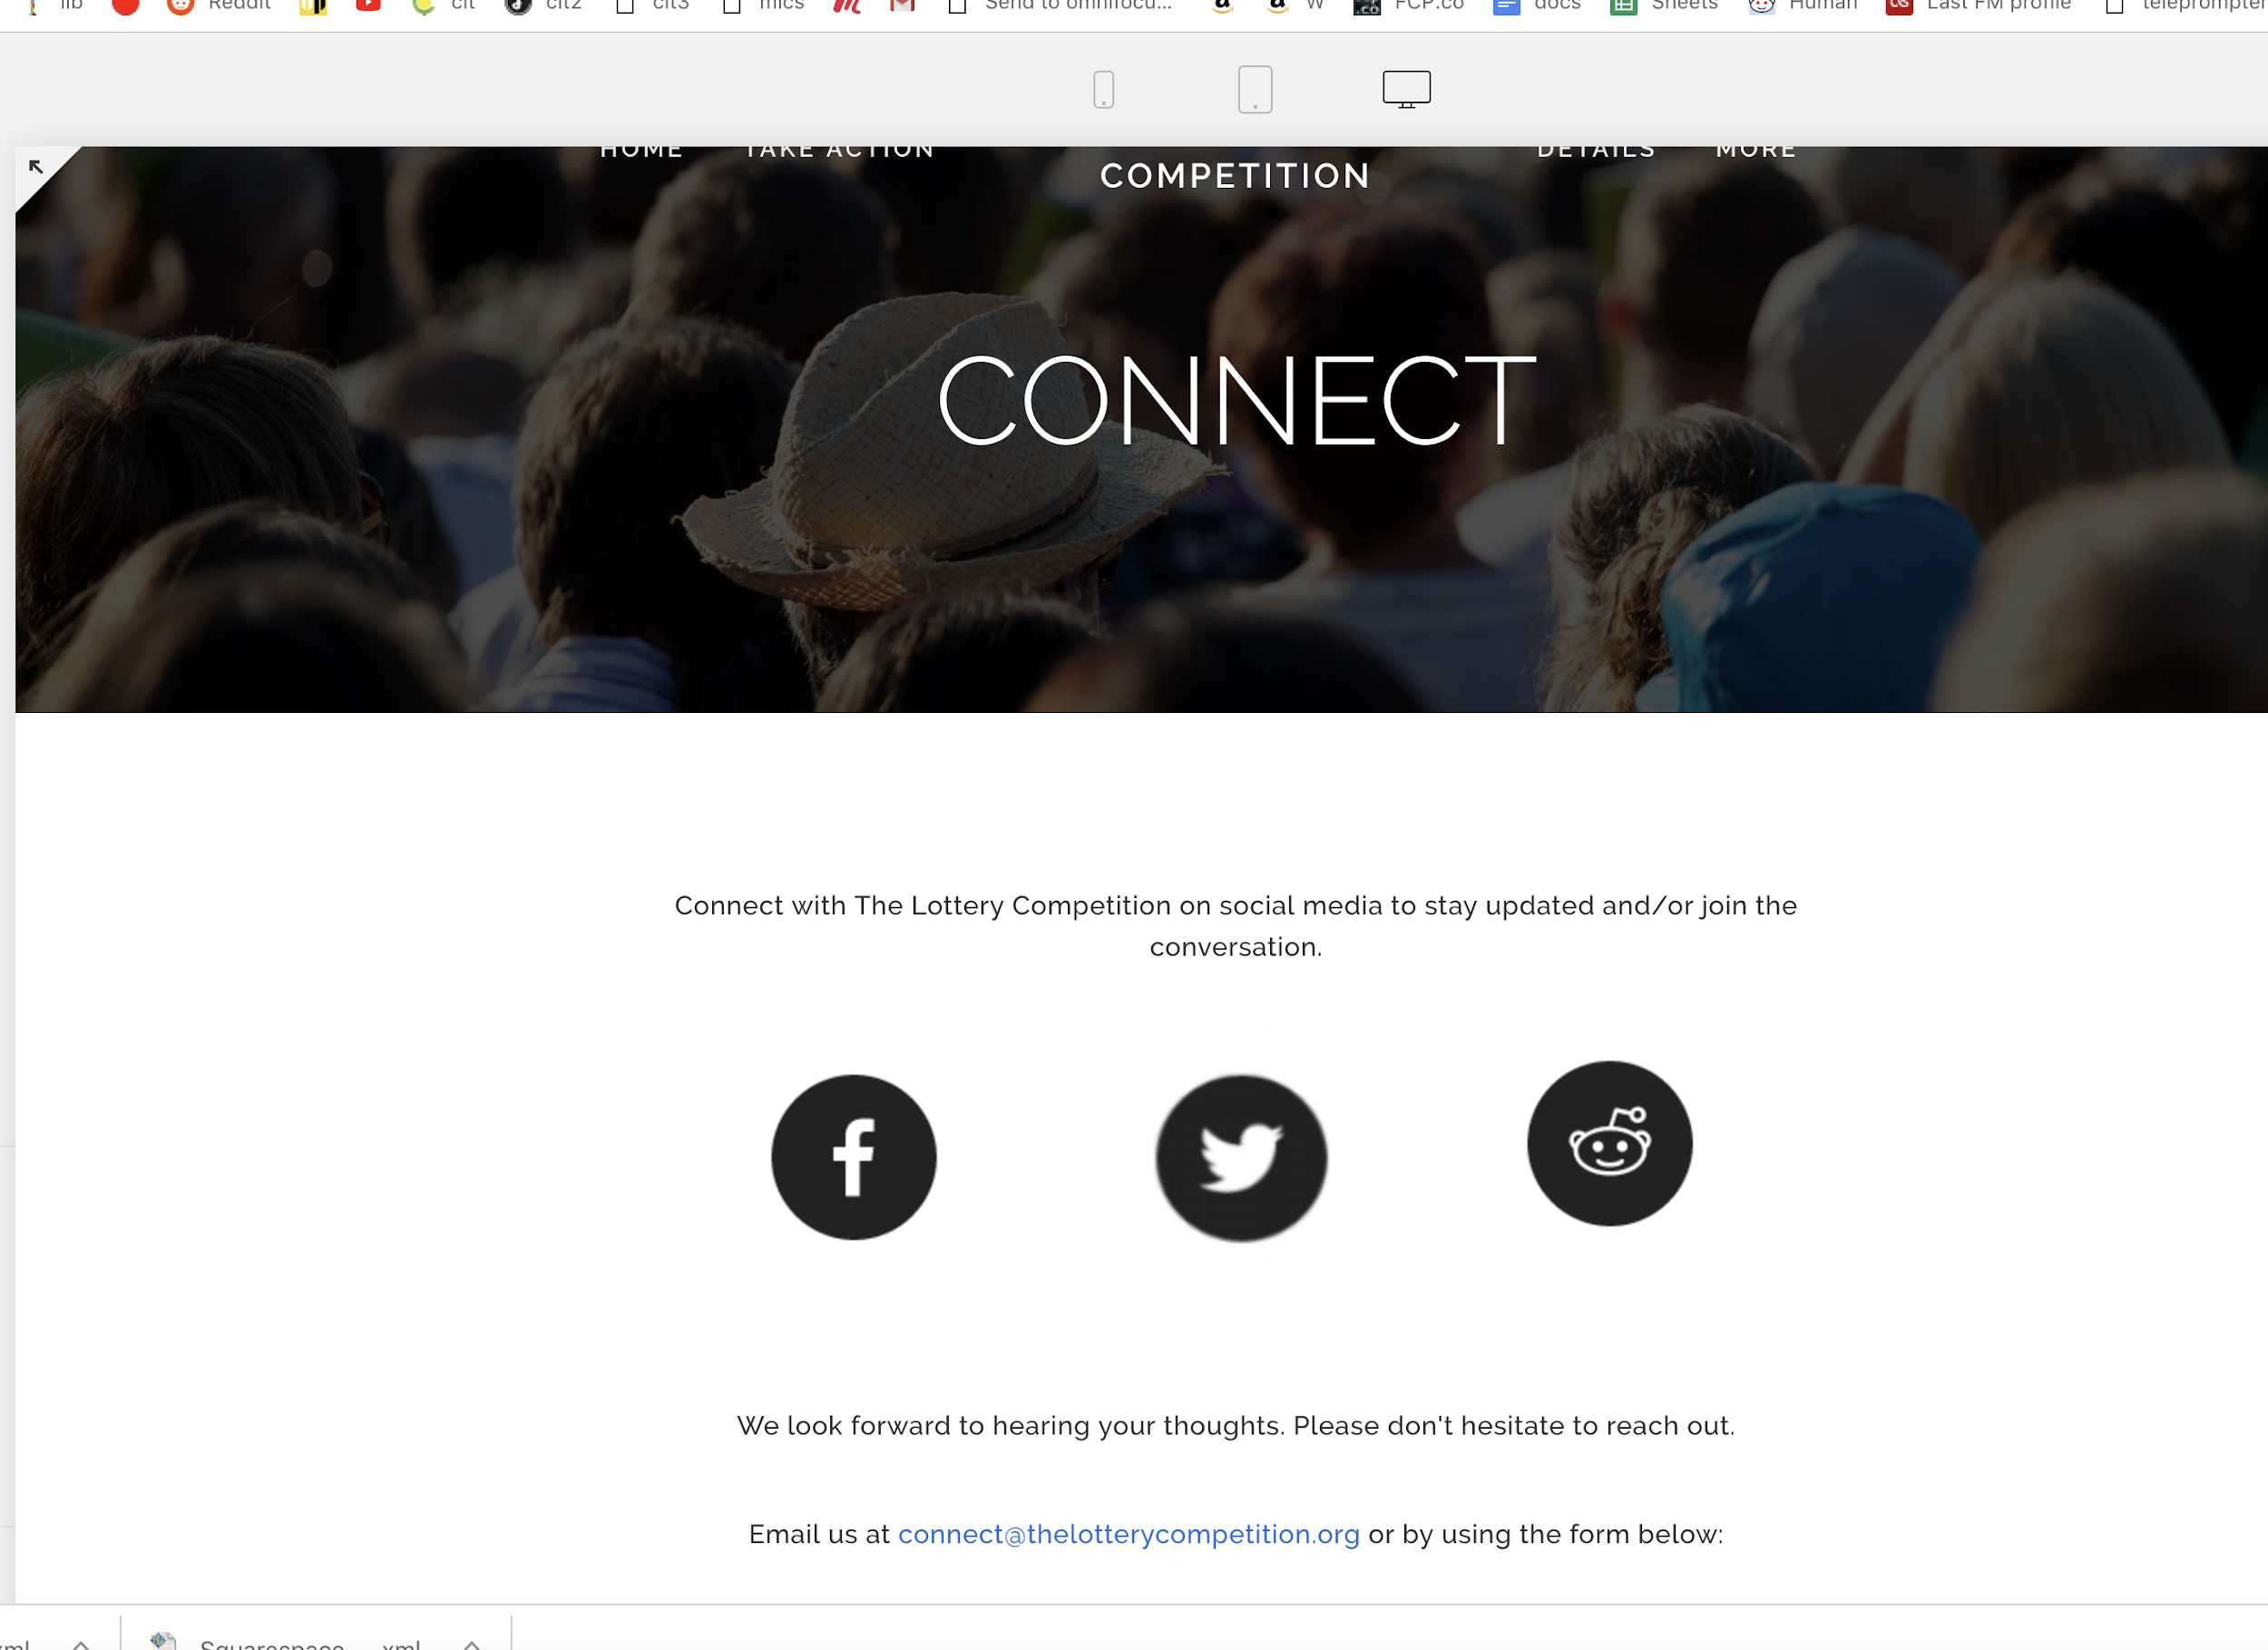

# **[THE LOTTERY COMPETITION](https://steven-oustecky-gg8f.squarespace.com/)**

[HOME](https://steven-oustecky-gg8f.squarespace.com/)

[TAKE ACTION](https://steven-oustecky-gg8f.squarespace.com/takeaction/)

[DETAILS](https://steven-oustecky-gg8f.squarespace.com/details/)

MORE

[CONNECT](https://steven-oustecky-gg8f.squarespace.com/connect/)

[ABOUT](https://steven-oustecky-gg8f.squarespace.com/about/)

## **About the Creators**

The Lottery Competition was created by Steven Oustecky and Dan Klimkowski. Neither had much previous interests or experience with lotteries, but they became interested in creating social good by fostering changes to lotteries after a curious Internet search led them to discover the scale of lotteries. They began working on the idea in September 2014.

Dan and Steve grew up both grew up in Islip, NY and have been friends since the third grade. Some of their favorite pastimes have included playing tennis, frisbee, and wiffle ball.

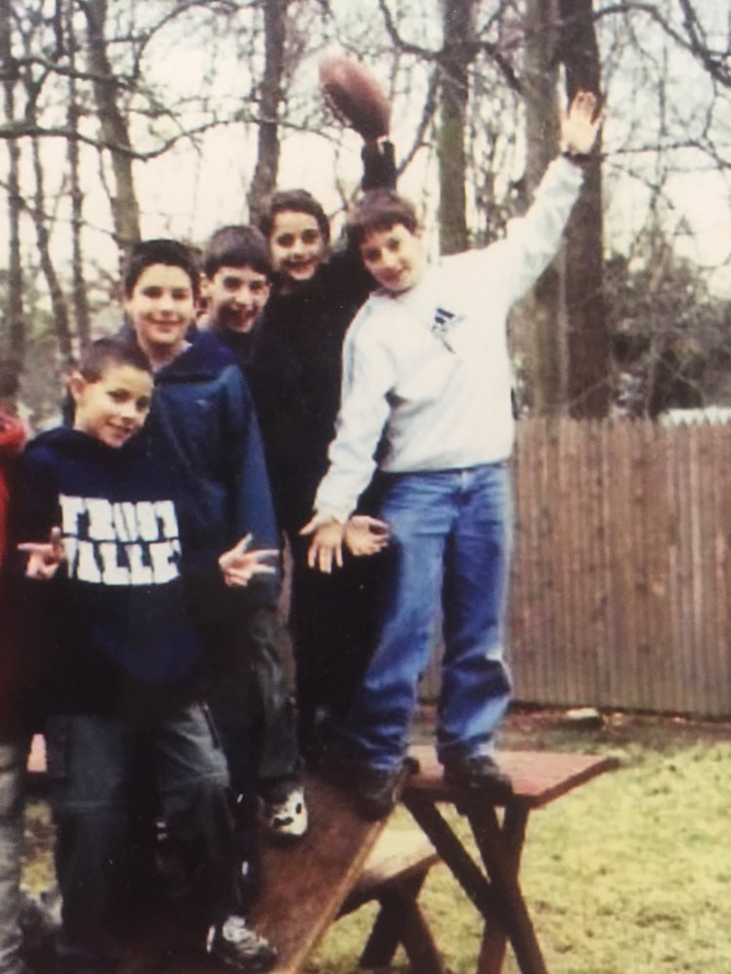

On a skateboard ramp with friends (Steve and Dan are on the left)



In high school



On a hike in 2015 (discussing The Lottery Competition)

Dan is a musician and filmmaker based out of Charlotte, NC. He loves to read and spend as much time as possible outdoors. Some of his favorite activities are camping, rock climbing, and mountain biking.

Dan studied Marketing and Finance at Fordham University and graduated in 2012. He became interested in social entrepreneurship after co-creating [Recycling Furniture](https://www.facebook.com/RecyclingFurniture/?ref=br_rs) in 2011. [Read Dan's story about this here.](https://medium.com/@danklimkowski/how-i-became-interested-in-social-entrepreneurship-5bfea325b62#.ba3k4hw9s)



Screen Shot 2017-01-28 at 11.14.54 AM.png

Screen Shot 2017-01-28 at 11.24.27 AM.png

Screen Shot 2017-01-28 at 11.14.44 AM.png

Screen Shot 2017-01-28 at 11.13.22 AM.png



Steven studied Geology at Boston University for his undergraduate degree. He now lives in San Diego, California and is building a nutritional supplement company. Steven enjoys spending time at the beach, weightlifting, and beach volleyball.

Steven has been influenced by [Peter Diamandis](https://en.wikipedia.org/wiki/Peter_Diamandis), [Ray Kurzweil](https://en.wikipedia.org/wiki/Ray_Kurzweil), [Thomas Paine](https://en.wikipedia.org/wiki/Thomas_Paine), [Nikola Tesla](https://en.wikipedia.org/wiki/Nikola_Tesla), [Albert Einstein](https://en.wikipedia.org/wiki/Albert_Einstein), and [Dr. Martin Luther King Jr](https://en.wikipedia.org/wiki/Martin_Luther_King_Jr.#Doctoral_studies).

Screen Shot 2017-01-28 at 11.14.44 AM.png

Screen Shot 2017-01-28 at 11.14.07 AM.png

Screen Shot 2017-01-28 at 11.14.54 AM.png

Screen Shot 2017-01-28 at 11.13.22 AM.png



Steve and Dan are not making money by creating The Lottery Competition. They are looking to connect with others. Please don’t hesitate to reach out.

## **Acknowledgements**

The Lottery Competition would not have been possible without a great deal of help from many close friends and family members.

It also would not have been possible without much help from the team at HeroX. You can learn more about HeroX [here](https://herox.com/). HeroX is a subsidiary of [XPRIZE](http://www.xprize.org/), which has been a major inspiration for The Lottery Competition. XPRIZE was founded by Peter Diamandis, who co-wrote [Bold](http://diamandis.com/bold). This book was extremely influential in the creation of The Lottery Competition.

The Lottery Competition was also inspired by many other incentive prize competitions throughout history, such as the 1927 Ortieg prize. The Ortieg prize inspired Charles Lindbergh to become the first person to fly across the Atlantic Ocean in 1927 (to win a prize of $25,000). You can learn more about the history of incentive prize competitions [here](https://en.wikipedia.org/wiki/Inducement_prize_contest).

Another major influence is the effective altruism movement, which you can learn about [here](https://www.effectivealtruism.org/). Of course, The Lottery Competition also wouldn't have been possible without the efforts of countless people who have previously researched lotteries and shared their findings. There are, of course, many others who have provided vital inspiration for The Lottery Competition. There's just not enough time to write. For all of these people, we are grateful.

Powered by [Squarespace](http://www.squarespace.com/)

